Uganda

## Freedom House political status

The data set shows the Freedom House political scores and status of the country each year.

## # A tibble: 19 x 5  
## country iso3c date mean status   
## <chr> <chr> <dbl> <dbl> <chr>   
## 1 Uganda UGA 1996 4 Partly Free  
## 2 Uganda UGA 1998 4 Partly Free  
## 3 Uganda UGA 2000 5.5 Partly Free  
## 4 Uganda UGA 2002 5 Partly Free  
## 5 Uganda UGA 2003 4.5 Partly Free  
## 6 Uganda UGA 2004 4.5 Partly Free  
## 7 Uganda UGA 2005 4.5 Partly Free  
## 8 Uganda UGA 2006 4.5 Partly Free  
## 9 Uganda UGA 2007 4.5 Partly Free  
## 10 Uganda UGA 2008 4.5 Partly Free  
## 11 Uganda UGA 2009 4.5 Partly Free  
## 12 Uganda UGA 2010 4.5 Partly Free  
## 13 Uganda UGA 2011 4.5 Partly Free  
## 14 Uganda UGA 2012 4.5 Partly Free  
## 15 Uganda UGA 2013 5 Partly Free  
## 16 Uganda UGA 2014 5.5 Not Free   
## 17 Uganda UGA 2015 5.5 Not Free   
## 18 Uganda UGA 2016 5.5 Not Free   
## 19 Uganda UGA 2017 5 Partly Free

## Freedom House classification of political change

The data set shows the GDP growth and the ecomic growth classification of the country each year.

## # A tibble: 19 x 4  
## country iso3c date politicalChangeFH  
## <chr> <chr> <dbl> <chr>   
## 1 Uganda UGA 1996 no change   
## 2 Uganda UGA 1998 no change   
## 3 Uganda UGA 2000 autocratization   
## 4 Uganda UGA 2002 democratization   
## 5 Uganda UGA 2003 democratization   
## 6 Uganda UGA 2004 no change   
## 7 Uganda UGA 2005 no change   
## 8 Uganda UGA 2006 no change   
## 9 Uganda UGA 2007 no change   
## 10 Uganda UGA 2008 no change   
## 11 Uganda UGA 2009 no change   
## 12 Uganda UGA 2010 no change   
## 13 Uganda UGA 2011 no change   
## 14 Uganda UGA 2012 no change   
## 15 Uganda UGA 2013 autocratization   
## 16 Uganda UGA 2014 autocratization   
## 17 Uganda UGA 2015 no change   
## 18 Uganda UGA 2016 no change   
## 19 Uganda UGA 2017 democratization

## Freedom House score trend

The plot shows the Freedom House scores trend of the country.

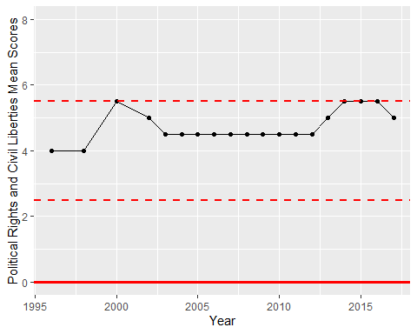

Freedom House Score Trend